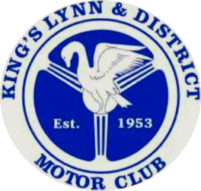

### King’s Lynn & District Motor Club Ltd

### www.kingslynndmc.co.uk

### presents its

46th Annual Charity Classic Car Rally

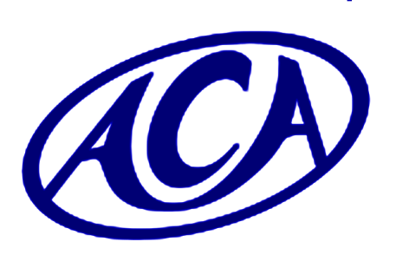

***sponsored by***

Anglia Car Auctions of King’s Lynn

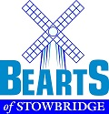

### 

Potato Storage Insight

### 

**Steve Cato Classic Restoration & Bodywork**

### in association with the Borough Council of King’s Lynn & West Norfolk

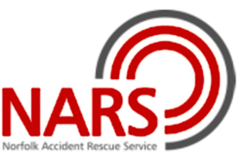

***AN EVENT IN AID OF***

### Norfolk Accident Rescue Service

### on Sunday 7th July 2024

EVENT INFORMATION, REGULATIONS & ENTRY FORM

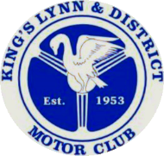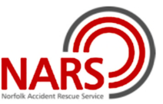**King’s Lynn & District Motor Club Ltd**

46th ANNUAL CLASSIC CAR RALLY

Sunday 7th July 2024

*in aid of Norfolk Accident Rescue Service*

Dear Classic Car Enthusiast,

**King’s Lynn & District Motor Club** invites you to enter our 2024 Annual Charity Classic Car Rally which is again being run in aid of the **Norfolk Accident Rescue Service**.

Our Club, which celebrated its 70th anniversary in 2023, is looking for your support for this annual meeting helping to raise money for this very worthwhile cause. Our popular three venue format is a well-established part of this event’s history which extends back to the 1970s. As ever, the focus is on driving our cars, enjoying the locations we visit and sharing the day with like-minded classic car enthusiasts, with the help of our generous entrants, supporters, sponsors and venues.

Sponsorship helps keep our entry fees to a modest level and allows more funds to be raised for our charities. We are again very grateful to **Anglia Car Auctions at King’s Lynn** for their continued support as our main sponsor. Providing our start venue again this year, for the first time, is another of our sponsors: **Bearts of Stowbridge,** who actually host their own classic car show every July**.** Thanks also go to our other sponsors who are all providing financial assistance: **Ottoway Carpentry & Building, Bennett & Co Estate Agents, Potato Storage Insight** and **Steve Cato Classic Restoration & Bodywork.**

From Bearts, we will be heading on a circular route around West Norfolk before we stop for a carvery lunch or picnic at **The White Pheasant Hotel at Lenwade**. In 2024, our rally is also teaming up with the King’s Lynn & West Norfolk District Council as part of a collaborative relationship which stems from our involvement with the Hunstanton Soapbox Derby. With the Council’s assistance, this year’s finish will be in a secured area on **The Green at Hunstanton,** where we will have access to the Town Hall for seating and refreshments whilst the promenade and its attractions are just a stone’s throw away.

All the details of the event are in the regulations that follow. We look forward to seeing you for another great day out on **Sunday 7 July**.

**Adrian Cunnington, Duncan Russell, Steve Tilburn & the KLDMC team**

King’s Lynn & DMC is a 

EVENT REGULATIONS

1. **King's Lynn & District Motor Club Limited will organise its 46th Annual Classic Car Rally, sponsored by Anglia Car Auctions, on Sunday 7th July 2024.**
2. The meeting will be run in accordance with Motor Sports UK regulations as a touring assembly, under certificate of permit exemption no. 135941. The meeting will be governed by the MSUK’s General Regulations, these supplementary regulations and any written instructions issued for the event. An MSUK Certificate of Exemption from permit has been issued.
3. This event is open to members and non-members of the promoting Club, with classic cars which are at least **15 years old**. If you are aware of others who may wish to enter, please give them a copy of the entry form or refer them to the Club’s website.
4. The event will raise funds in aid of the **Norfolk Accident Rescue Service (NARS,** *see panel below***)**▼ Donations will be at the discretion of the King’s Lynn & DMC Committee and details published on the Club website.



NARS is a charity that gives crucial first response expert medical help at the scene of serious road crashes and other life-threatening medical emergencies. The doctors and paramedics who volunteer to NARS have received extra training to provide high level trauma care and can administer specialist drugs at the scene of a crash or cardiac arrest, vital during the critical moments of an incident.

**NARS receives no funding from Government or the NHS. It relies wholly on the support of the public to sustain this incredible service.**

**www.nars.org.uk**

1. Entries open on publication of these regulations and close on **Friday 7th June 2024** or when the maximum entry is reached, if earlier. The maximum entry is 100 cars. Late entries cannot be accepted. Entries must be sent to the Entries Secretary: **Peter Horsburgh, The Highlands, Sedgford Road, Docking, Norfolk. PE31 8PN.**
2. Other officials: *Clerk of the Course:* Adrian Cunnington; C*lub Secretary*: Duncan Russell; *Club* *Safeguarding Officer*: Stephen Tilburn; *Chief Marshal:* Andy Congreve; *Club* *Treasurer:* Helen Haylock; *Logistics Officer:* Paul Smalley.
3. Vehicle classes are: Vintage, PVT & Fifties (up to 1959); Historic Classic (1960-74); Post-Historic Classic (1975-89) and Modern Classic (1990-2009). The organisers reserve the right to adjust or amalgamate classes if necessary.
4. The event will start from the premises of **H & C Beart Ltd**, The Causeway, Stowbridge, King’s Lynn, PE34 3PD (https://[www.bearts.co.uk](http://www.bearts.co.uk); what3words///case.cars.devoured; OS ref 143/607¼070¼; turn off the A10, 1½ miles north of Downham Market). Fuel is available within 5 miles of the start at multiple outlets on the A10 and A1122.
5. Registration will take place on arrival at the start from 9.00 am. Tea, coffee and biscuits will be provided at the start and are included in the entry for all participants.
6. **All entrants must sign the declaration at Registration to confirm that their car is road legal and that they have valid insurance for the event.**
7. Cars will leave the start from approximately 10.15 am on a suggested scenic route of *c.* 50 miles which will be provided to participants in the form of a road book with mileages and tulip diagrams. This will be supplemented with arrows, where appropriate.
8. Cars will be identified by numbered rally plates issued at registration which must be fixed to the front of each vehicle. Plastic tie straps will be supplied.
9. The lunch halt will be at **The White Pheasant Hotel**, Lenwade House Drive, Lenwade, NR9 5QP (<https://thewhitepheasantnorfolk.co.uk>; O.S. map reference 133/095184).
10. Cars will arrive at the lunch halt at approx12.00 noon. There is ample parking but please ensure you park as directed by our marshals.
11. A two-course hot carvery Sunday lunch may be *pre-ordered* at the time of entry at **£19.00** per person. Please indicate any dietary restrictions on the entry form. Alternatively, entrants may bring a picnic. A licensed cash bar and toilet facilities will be available at the Hotel for the use of all participants.
12. Over lunch, judging of entrants will be by other competitors in their class for Class Award trophies (see para 7) and for the ***Adrian Flux Insurance* Shield** for the overall winner voted ‘Car of the Day’.
13. A representative from our beneficiaries NARS, or their delegate, will select the winner of the ***Anglia Car Auctions* Trophy** for their choice of ‘best car with popular appeal’.
14. The KLDMC marshals will judge the **Hillebrand Bos Memorial Trophy**, awarded to those participants ‘Most Appropriately Attired’ for their vehicle. This award is open to all entrants; please do support it by wearing something that is (or looks like it is) from your car’s era if you can.
15. Cars will leave the lunch halt at ~1.45 pm and follow a suggested scenic route of *c.* 35 miles to reach the finish by *approx.* 3 pm.
16. The event will finish in front of Hunstanton Town Hall at The Green, Hunstanton, Norfolk. PE36 6BQ (OS map ref. 132/673409½).
17. At Hunstanton, all entrants will be able to access the Town Hall Café (specifically open for our exclusive use) and outside areas.
18. At the finish, entry to the Café will be by pre-paid passes provided in your entry pack (2 per car).
19. The Presentation of Awards (to be held for a maximum of 12 months) will take place next to the cars at about **4.15pm**.
20. The entry fee is **£30** per car. Please use the official entry form provided. Photocopies of the entry form are acceptable. Entries close on **Friday 7th June 2024**.
21. Please pay for both your food order and entry fee at the time of entry. **BACS payment is preferred**; please see the entry form. Note that any cheques will not be presented before 10th June.
22. Acknowledgements of entry and final instructions will be sent to entrants by e-mail wherever possible so, if you have an e-mail address, please provide details on the entry form. Periodic updates will also appear on our event webpage at www.kingslynndmc.co.uk. Hard copy acknowledgements will be provided only if an SAE is included.
23. Final instructions will be issued by email or post from Friday 14th June 2024. All other information you need will be included in your entrant’s pack issued at Registration at the start on the day.

**For more information, contact**

**ADRIAN CUNNINGTON on 01406 364795, DUNCAN RUSSELL on 01760 721375 or, preferably, e-mail** [**kldmc.classic@btinternet.com**](mailto:kldmc.classic@btinternet.com)

ACKNOWLEDGEMENTS

The organisers thank the following for their assistance with this event:

|  |  |
| --- | --- |
| **ANGLIA CAR AUCTIONS, KING’S LYNN** | |
| **H. & C. BEART LTD., STOWBRIDGE** | |
| **BENNETT & CO, ESTATE AGENTS, KING’S LYNN** | |
| **BOROUGH COUNCIL OF KING’S LYNN & WEST NORFOLK**  **HUNSTANTON TOWN COUNCIL** | |
| **MEMBERS OF KING’S LYNN & DISTRICT MOTOR CLUB**  **MOTOR SPORT UK**  **NORFOLK ACCIDENT RESCUE SERVICE**  **NORFOLK CONSTABULARY**  **OTTOWAY CARPENTRY & BUILDING, DERSINGHAM**  **POTATO STORAGE INSIGHT, GEDNEY DYKE**  **STEVE CATO CLASSIC RESTORATION & BODYWORK, TOTTENHILL**  **WHITE PHEASANT HOTEL, LENWADE** | |
|  |  | |

## 

## Anglia Car Auctions

## From modern second-hand vehicles to classic cars and motorbikes for sale from motor traders, collectors and private individuals, Anglia Car Auctions holds regular auctions at its King’s Lynn base.

**ACA was founded in 1995 by owner Lyn George and a friendly, professional and competitive service is provided to ensure that you get the best deal when it comes to buying or selling.  So, whether you’re a motor trade professional or a private individual wanting to buy or sell via an auction for the first time, Anglia Car Auctions is the place for you.**

**Our weekly modern car auctions are held every Wednesday at 6pm (excluding weeks preceding a classic auction) and include previously owned vehicles of all ages, which are offered by private individuals, car dealerships, traders and finance companies.**

**Our classic auctions are held five times a year, with preview days on the preceding Thursday and Friday and the sale over a weekend. (Sorry there are no preview evening events for classics this year). We are one of the very few auction houses operating a ‘drive through’ classic sale rather than the cars being offered from a static position.**

**Our remaining classic car auction sale dates are scheduled in 2024 for: 22 & 23 June; 24 & 25 August; 2 & 3 November**

**Please check our website for latest information**

**The Cattlemarket, Beveridge Way, King's Lynn, Norfolk, PE30 4NB. 🕾 01553 771881** [**www.angliacarauctions.co.uk**](http://www.angliacarauctions.co.uk)

**Steve Cato Classic Restoration & Bodywork**

**Potato Storage Insight Ltd**

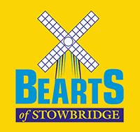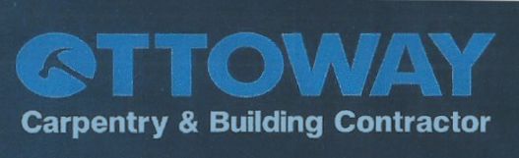

Beart’s Charity Classic Car Evening

Thursday 18 July 2024

www.bearts.co.uk

Hunstanton Soap Box Derby

Sunday 22 September 2024

For information please go to

**www.west-norfolk.gov.uk**

King’s Lynn & District Motor Club Ltd

46th Annual Charity Classic Car Rally

Sunday 7th July 2024

ENTRY FORM

|  |  |  |  |  |  |
| --- | --- | --- | --- | --- | --- |
| **ENTRANT** – Name: | | | | | |
| Address: | | | | | |
|  | | | | | |
|  | | | | | |
| Post Code: | | Tel. No: | | | |
| **E-mail:** | | |  | | |
| **DRIVER** – Name (only if different from ENTRANT): | | | | | |
| **CAR** – Make: | | | | | |
| Model: | | | | | |
| Colour: | Year: | | | Reg No: | |
| ENTRY FEE: £30.00 per car  FOOD: TWO COURSE LUNCHES @ £19 per head, payable with entry – please state the number required | | | | | **£ 30 - 00**  **£ -** |
| |  | | --- | | Dietary requirements? | | | | | | **TOTAL PAYMENT**  **£ -** |
| Please mark as appropriate:  I agree to abide by the regulations for this event and any reasonable organiser’s requests.  I enclose my cheque no. ………………………… payable to ‘King’s Lynn & District Motor Club Ltd’  I’ll pay by BACS: King’s Lynn & District Motor Club Ltd. Sort code: 53-61-38. Account: 04048679 On or before **7th June 2024**, I will make payment including my surname as a reference (this *must* be quoted). Unpaid entries will be invalid.  Signed ................................................................................... Date ...........................  All entry forms must be signed by the entrant and sent to:  **P Horsburgh, KLDMC, The Highlands, Sedgford Rd, Docking, Norfolk. PE31 8PN**  Tel: **01485 517178**. Email: **p111h@hotmail.com** to arrive by **Friday 7th June 2024**. | | | | | |

**!**

The organisers reserve the right to cancel the event without notice, refuse entries or merge classes as necessary.

**IMPORTANT: Data Protection/GDPR: Details supplied on this form are held on computer solely for promotion of MSUK-affiliated Motor Club classic car events. PLEASE MARK THIS BOX to indicate your willingness for us to contact you again. We cannot do so without your express permission** >